

**Lesson 5**

**Present Continuous. Revision Simple present + Countries and landmarks of the world.**

**Step 1:** Present continuous

Do you remember how we form the Present continuous?

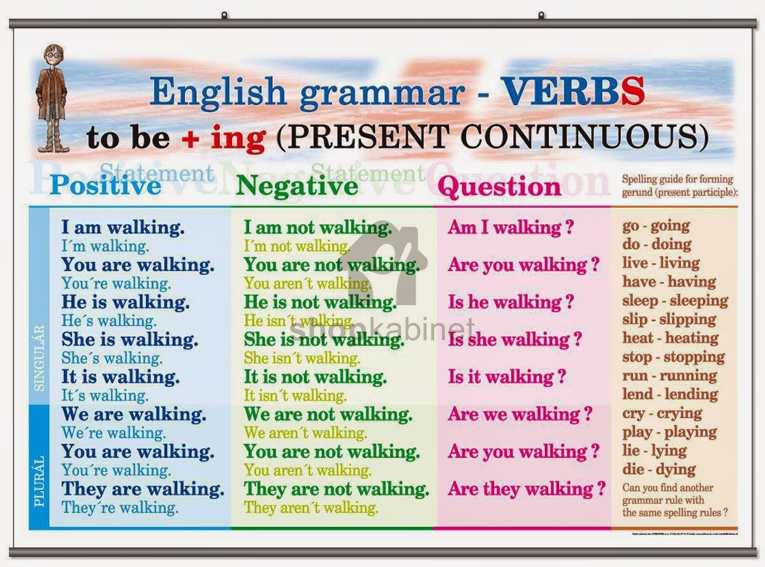

**Step 2:** Present continuous use

When do we use it?

Τον χρησιμοποιούμε για να μιλήσουμε:

1)για μία πράξη που γίνεται αυτήν την στιγμή και διαρκεί.

2) ή αυτήν την περίοδο - προσωρινά όχι μόνιμα.

3)για κάτι που θα γίνει στο μέλλον σίγουρα 90%.

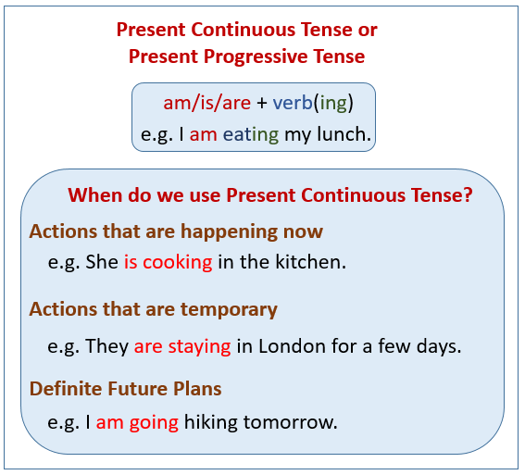

**Step 3:** Do the exercise and send back your answers to me as a message in e-class or to my e-mail address

NAME: DATE:

GRAMMAR QUIZ PRESENT CONTINUOUS

*Complete these sixteen questions to score your knowledge of PRESENT CONTINUOUS.*

|  |  |  |  |
| --- | --- | --- | --- |
| 1. | I am watching TV and my brother | 9. | It’s very noisy upstairs! |
|  | … a book. |  | What …? |
|  | a) reading |  | a) are they doing |
|  | b) is reading |  | b) they doing |
|  | c) reads |  | c) do they do |
| 2. | Thomas and Patrick … outside | 10. | (A) Are they working now? |
|  | in the yard now. |  | (B) No, they …. |
|  | a) are playing |  | a) aren’t |
|  | b) is playing |  | b) don’t |
|  | c) plays |  | c) isn’t |
| 3. | (A) … doing? | 11. | I … dinner because we ordered |
|  | (B) I am washing dishes. |  | pizza a few minutes ago. |
|  | a) What are you |  | a) am not making |
|  | b) What you |  | b) don’t make |
|  | c) What do you |  | c) not make |
| 4. | They … eating their dinner right now | 12. | (A) … right now? |
|  | because their food is too hot. |  | (B) Yes, he is. |
|  | a) not |  | a) He sleeps |
|  | b) don’t |  | b) Is he sleeping |
|  | c) aren’t |  | c) He sleeping |
| 5. | (A) Are you studying English now? | 13. | What … that cat doing over there |
|  | (B) Yes, I …. |  | by the chair? |
|  | a) do |  | a) is |
|  | b) am |  | b) are |
|  | c) are |  | c) does |
| 6. | (A) … are you doing? | 14. | Why are we waiting? Who … |
|  | (B) I’m taking a test. |  | for? |
|  | a) What |  | a) we are waiting |
|  | b) Where |  | b) are we waiting |
|  | c) When |  | c) we wait |
| 7. | I can’t talk to you right now | 15. | (A) … is driving the car? |
|  | because I …. |  | (B) David is driving the car. |
|  | a) am study |  | a) Where |
|  | b) are studying |  | b) What |
|  | c) am studying |  | c) Who |
| 8. | He usually goes for a walk at this | 16. | (A) Is your friend sitting down? |
|  | time, but he … for a walk now. |  | (B) No, …. |
|  | a) doesn’t go |  | a) not |
|  | b) not go |  | b) he doesn’t |
|  | c) isn’t going |  | c) he isn’t |

**Step 4:** Do this present continuous quiz and check out your score.

<https://www.englishclub.com/grammar/verb-tenses_present-continuous_quiz.htm>

**Step 5:** Play now the following game to check if you remember Simple Present and Present Continuous. Click on the picture.

<http://photodentro.edu.gr/aggregator/lo/photodentro-lor-8521-3397>

**Step 6:** Let's listen to a song about our world.

Listen to the song and sing it if you want.It is about people and places around the world

<https://learnenglishkids.britishcouncil.org/songs/one-small-world>

**Step 7:** Check out the lyrics (= στίχοι) of the song "one small world"

Do you understand them?The song talks about countries of the world and their landmarks(=αξιοθέατα)

<https://learnenglishkids.britishcouncil.org/sites/kids/files/attachment/songs-one-small-world-lyrics.pdf>

**Step 8:** Do the exercises of the song.

<https://learnenglishkids.britishcouncil.org/sites/kids/files/attachment/songs-one-small-world-worksheet.pdf>

**Step 9:** Now check out the answers and correct your own exercises.

<https://learnenglishkids.britishcouncil.org/sites/kids/files/attachment/songs-one-small-world-answers.pdf>

**Step 10:** Memory game with European flags

Can you find the flags and match them? See the countries also.

<https://europa.eu/kids-corner/memorygame/index_en.htm#/choose_level>

**Step 11:** Match the landmarks from around the world with their picture.

<https://learnenglishkids.britishcouncil.org/word-games/landmarks-1>

See you next time!!

